

***Clostridioides difficile (C diff) New Testing Communication***

**Go-live – March 15, 2021**

**As Parkview Health continues to see high rates of reportable hospital-onset *C diff* infections, the Allen County *C diff* Reduction Taskforce remains diligent in implementing evidence-based practices with laboratory testing, clinical diagnosis, and disease therapy. On March 15th, Parkview will be going-live with a new and improved testing methodology specifically for *C difficile*:**

***C diff* Pathway. The testing algorithm will start with molecular testing for toxigenic *C diff*. If positive for toxigenic *C diff*, the test will reflex to a Toxin test for identification of toxin presence in the stool. The nurse will collect raw, loose stool in a cup. If the stool is not loose, lab will reject the specimen.**

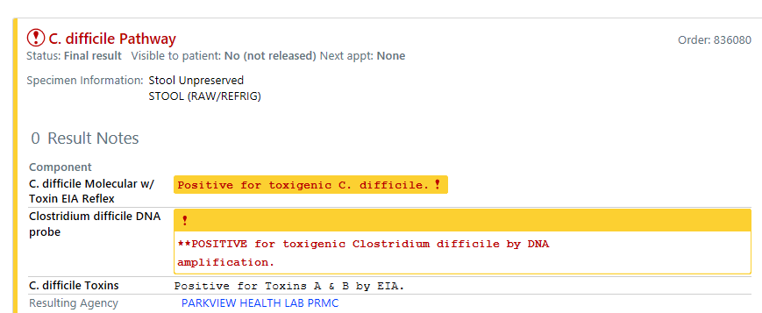

**Reminder: GI Biofire (w/oCDIFF). This panel no longer includes the *C diff* target.**

*Please contact Infection Control Practitioners, Nursing Educators or IS Specialist for any questions.*

***Excellent care, Every person, Every Day!***